

**How to prepare frozen meals**

**Microwaving your meal:**

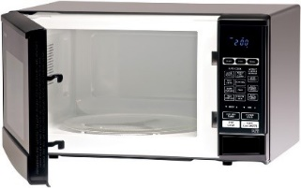

**All Meal Trays are Safe to Microwave**

**And They are Also Safe to Heat in the Oven**

You may want to take tomorrow’s meal from the freezer and let it thaw overnight in the refrigerator. DO NOT leave food out on the counter to thaw.

**Heating Time**

1. If thawed, heat first for **1-** **2 minutes**
2. If frozen, heat first for **6 minutes**
3. Let stand for 1 minute
4. Remove the food from the microwave, it may be HOT!



**How to prepare frozen meals**

**Microwaving your meal:**



**All Meal Trays are Safe to Microwave**

**And They are Also Safe to Heat in the Oven**

You may want to take tomorrow’s meal from the freezer and let it thaw overnight in the refrigerator. DO NOT leave food out on the counter to thaw.

**Heating Time**

1. If thawed, heat first for **1 - 2 minutes**
2. If frozen, heat first for **6 minutes**
3. Let stand for 1 minute
4. Remove the food from the microwave, it may be HOT!