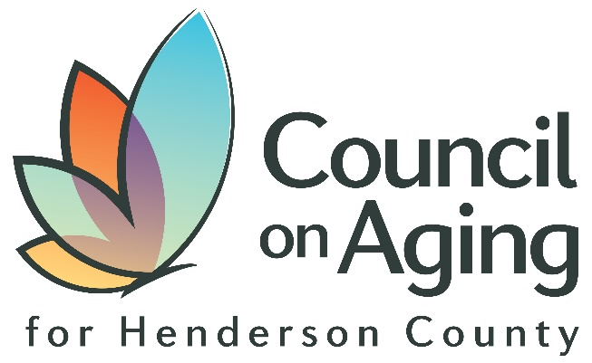

The Council on Aging for Henderson County, in partnership with AdventHealth is excited to offer a series of community education events focused on the needs and care of our aging population. Join us for this dynamic speaker series which offers information and resources on topics that affect older adults. Register for events 1 week before the date.
Register at AdventHealthNC.com/Events or Call 855-774-5433
The Age-Friendly Speaker Series events are held at the Age-Friendly Center at the AdventHealth Multispecialty at Laurel Park, 1881 Pisgah Drive, Hendersonville NC 28791
Doors open at 5:30 p.m. Presentations begin at 6:00 p.m.
Program for Assistance Care for the Elderly PACE
Health Plan Enrollment & Outreach Specialist, Jamie Stanley reviews this program that provides day-time medical care, therapy, and activities. 07/09/2024

Care Navigation – Health Decline Transitions
Four Seasons Compassion for Life reviews health decline and navigating prognosis and transitions with Judy Edwards and Gage Comeaux. 05/07/2024

Let’s Get Social – Health Benefits of Socialization
Jim Kelly is the President and CEO of Aging Projects, Inc., and reviews how social engagement improves well-being and supports healthy aging. 07/23/2024

Professional Care Management and Advocacy
Karen Wolfrom of Holistic Elder Services shares how her care management services provide individuals and families with ongoing support. 05/21/2024

Home Navigation & Aging-In-Place Strategies
Katelyn Rowe, PT, DPT with PTSolutions discusses safe home navigation and aging in place adaptations involving care level transitions. 08/06/2024
11/28/2023
11/28/2023 11111/28/2023
Parental Estrangement Awareness & Restoration
PEAK provides support to parents related to the trauma of parental estrangement of adult kids. Fe Avis discusses restoration strategies. 06/11/2024

Cyber Security – The Anatomy of a Scam
John Lake will equip attendees with security steps to safeguard their financial interests and to ensure protection from cyber criminals. 08/20/24
2023
Caregiver Support Services Care Management
Sheila Galloway, CCM reviews her certified caregiver manager roll discusses health decline and care navigation and advocacy. 06/25/2024

